CS 577 – HW 4

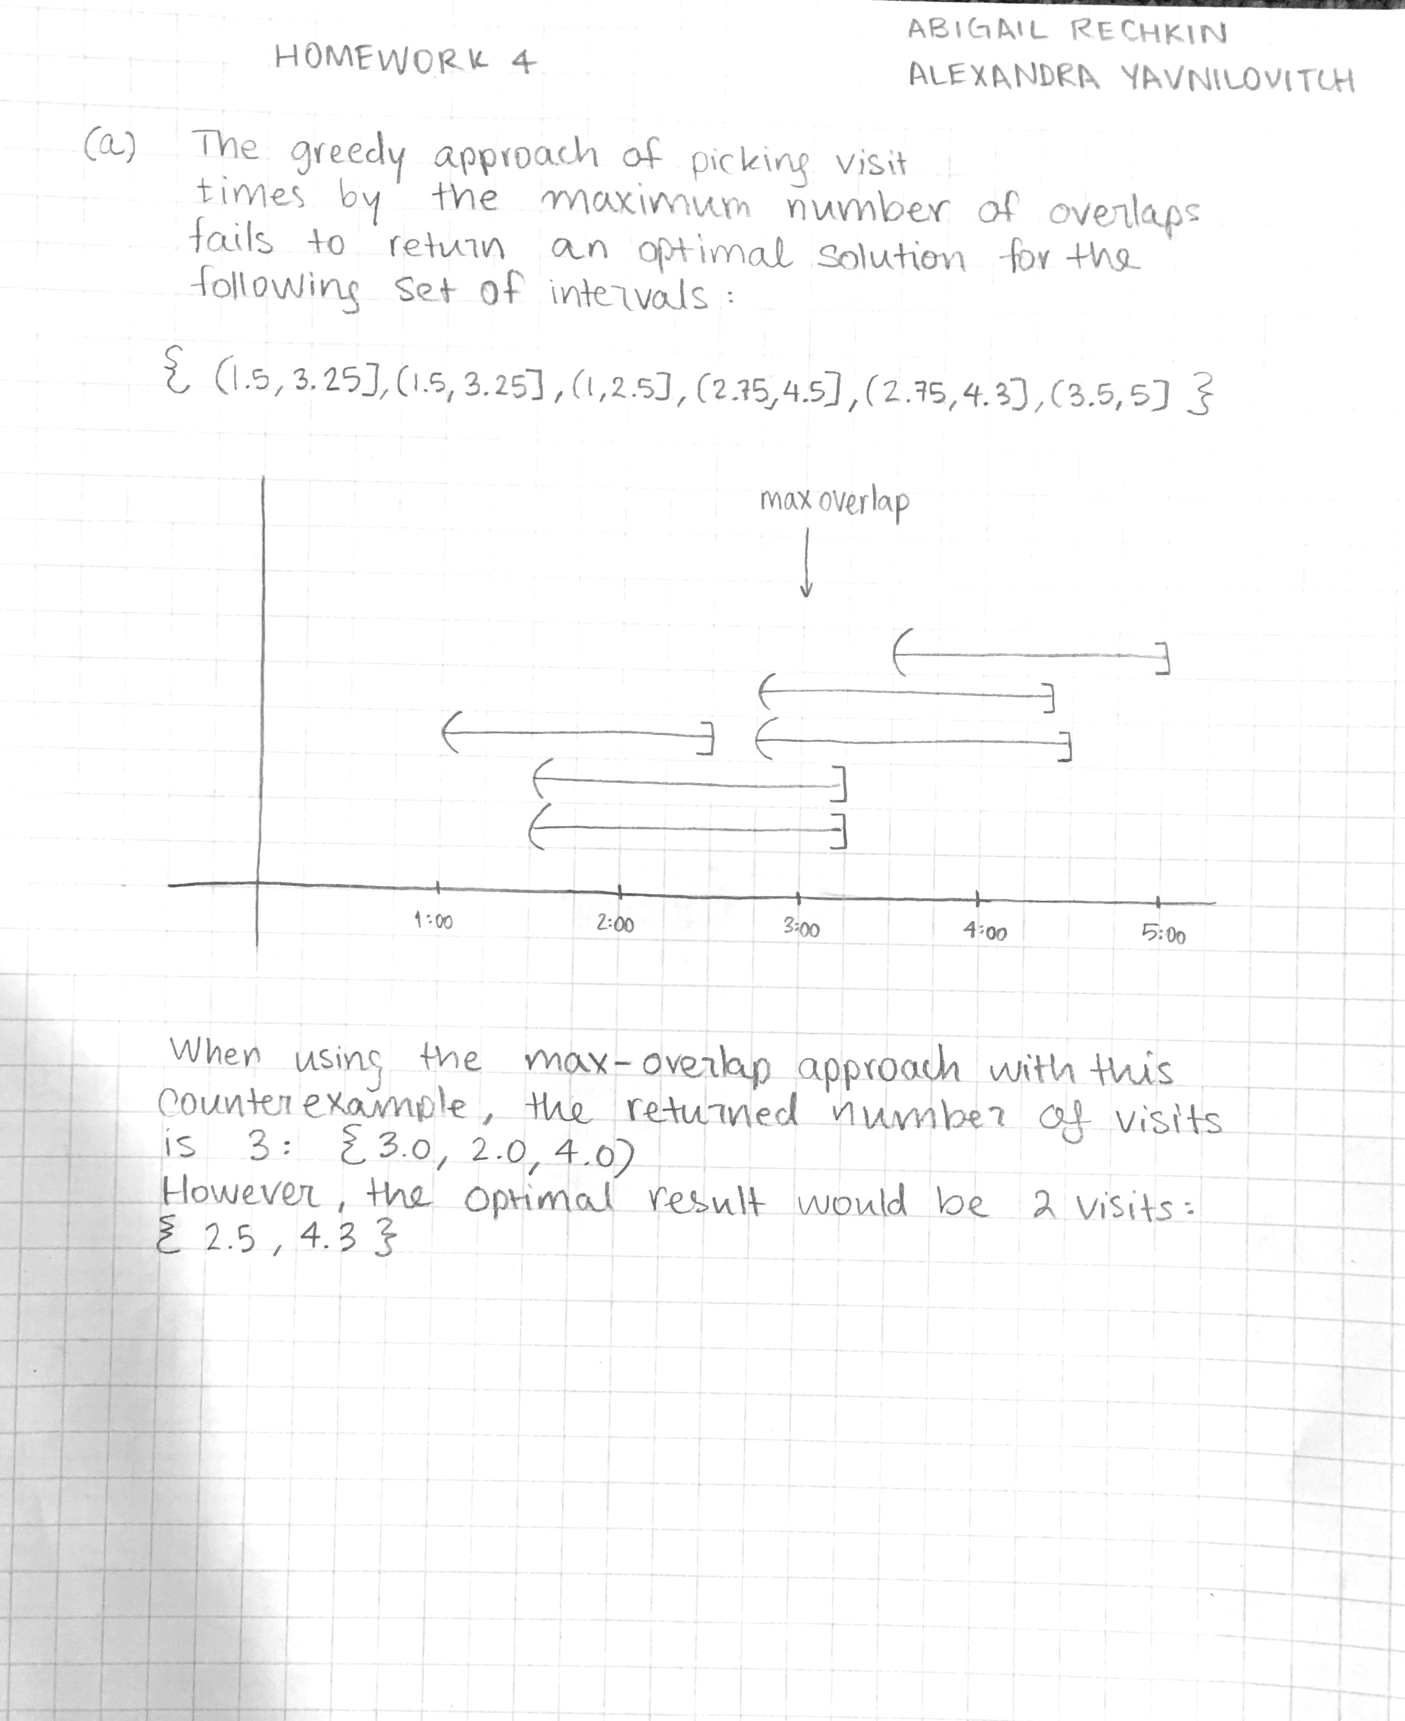Abigail Rechkin, Alexandra Yavnilovitch

